Quarterly Report Format (DTCC to STCC)
DISTRICT TOBACCO CONTROL CELL: CHAMPHAI DISTRICT
REPORT FOR THE QUARTER ENDING: 30th JUNE, 2016
PART-A
S. No | Activities | YES/NO | Reasons, if the answer is No
1. | Whether District Cell has been set up | Yes
2 | Status of recruitment of staff in the District Cell  - District Consultant | Yes
2 | – Psychologist | Yes
2 | - Social Worker | Yes
2 | - Data Entry Operator | Yes
3 | Whether District Level Co-ordination Committee (DLCC) has been constituted | Yes, In the form of District Level Task Force (Tobacco Control)
4. | Whether District Level Monitoring Committee for Section – 5 of the COTPA has been constituted | Yes
5. | Whether COTPA and its rules have been displayed on the official district website | No | Champhai District does not have separate official district website
6. | Whether challenging mechanism for COTPA has been set up at District Level | Yes
6. | Whether separate head of account has been opened for deposit of challan amount at district level | No | Separate head of account is not opened at District level since challan can be deposited into the account head identified by Govt. of Mizoram for the whole state.
6. | Whether challan books have been received from STCC | Yes
6. | Whether challan books have been distributed to authorized officers | Yes
6. | Whether enforcement squads have been set up in the district to monitor compliance of COTPA | Yes
6. | Whether compliance of COTPA has been integrated in the monthly crime review meetings | No | Request has been made by us but action awaited from their end
7. | Whether Utilization Certificate has been submitted for the previous financial year | No | Provisional Utilization Certificate has been submitted to NHM Mizoram
8 | Whether Statement of Expenditure has been submitted for the previous financial year | No | Provisional Utilization Certificate has been submitted to NHM Mizoram

PART-B

S.No | Activities | During the quarter | Up to the quarter in the Financial Year
1. | No. of meetings of the DLCC with dates | 0 | 0
2. | Visits conducted by the enforcement squads | 34 | 34
2. | Persons challaned and amount collected (information to be given month-wise in the format as annexed ) | Section 4 COTPA: Offenders 09  Total No of fines  Collected: Rs.450.00/- | Section 4 COTPA: Offenders 09  Total No of fines  Collected:Rs.450.00/-
2. | Complaint received through National Violations helpline | None | None
2. | Detail of such complaints where actions has been taken | None | None
3. | Training/sensitization programmes for different stakeholders organized by DTCC | 2 | 2
3. | Participants in the trainings/sensitization programmes organized | $$157$$ | $$157$$
4. | Types of IEC materials adapted/developed by DTCC (e.g. posters/stickers/handouts/wall paintings/hoardings etc) | 02  1. Hoarding  2. Wall Painting | 02
5. | PHCs, CHCs, Gov’t buildings, schools and other public places covered with these IEC materials | 33 | 33
6. | Schools covered in the School Programme by the DTCC  (i) Public Schools  (ii) Private Schools  (iii) Coaching Institutes | 24  12  00  Out of 36 schools 33 schools were covered without any cost incurred | 24  12  00  Out of 36 schools 33 schools were covered without any cost incurred
6. | Details of children covered in the School Programmes | 3321 | 3321
6. | Details of School Programmes conducted | Primary – 12  Middle – 14  High School - 10 | Primary – 12  Middle – 14  High School - 10
7. | Details of meeting held with other relevant State Govt. departments | 11  1) Meeting was held with BDO, Ruantlang regarding Tobacco Free Village on 11th April 2016  2) Meeting was held with SDPO on 16th April 2016 regarding In-Service Training on Tobacco Control  3) Meeting was held with DC Champhai regarding Observation of WNTD on 21st May 2016  4) Meeting was held with Legal Metrology on 24th May 2016 regarding Joint Operation against Contraband Cigarettes  5) Meeting was held with 1st Class Magistrate regarding on-going cases under Section 7 of COTPA on 14th June 2016  6) Meeting was held on 14th June 2016 with Asst. Public Prosecutor court matters.  7) Meeting was held with BDO Ruantlang on 16th June 2016 regarding on-going activities for Tobacco Free Village  8)Meeting was held with DNO on 17th June 2016 regarding plan of action  9) Meeting was held with Deputy Medical Superintendent, Civil Hospital Champhai regarding TCC on 20th June 2016  10) Meeting was held with Deputy Commissioner on 20th June 2016 regarding implementation of Block Level Coordination Committee  11) Meeting was held with DNO on 28th June 2016 regarding upcoming quarterly review meeting | 11
7. | Details of training programs of other departments in which DTCC participate and made presentations on tobacco control | 03  1) Participated in MHIP New Champhai Silver Jubilee celebration on 19th April 2016  2) Participated in Seminar on No Tobacco organized by United Pentecostal Church Khawzawl on 20th April 2016  3) Also participated in In-Service Training of Police Personnel of Champhai District on 26th May 2016 | 03
8. | Details of meetings held with civil society organizations and professionals bodies (e.g. NGOs, NSS, NCC, IDA, IMA etc) | 03  1) Meeting was held with Bethel Fruit Grower Society  2) Meeting was held with Producer of Sudden Muanga Film  3) Meeting was held with VL Sahdah Nuai | 03
9. | No. of Blocks where Block Level Coordination Committee have been set up | 00  1 | 00  1
9. | No of villages where Village Level Committee have been set up | 00  1 | 00  1
10. | Details of TCCs set up in the district (Indicate separately details of TCCs set up in the district hospital, other government set-ups, NGOs,private set-ups,NGOs,private set ups etc) | TCC has been set up at District Hospital Champhai w.e.f July 2015 | Nil
 | - Whether staff is in place in these TCCs | Yes | Yes
 | - Whether counselors working in these TCCs are formally trained in cessation activities ( indicate separately the total number of counselor in place and the number of counselors who have received formal training) | Yes  - Total - 1  - Trained Counselor - 1 | Yes  - Total -1  - Trained Counselor - 1
 | - Have the TCCs arranged for any cessation trainings for healthcare providers/workers? If yes, indicate the number of trainings undertaken with details. | 01 Training, 40 participants | 01 Training, 40 participants
 | - Whether pharmacological treatment of tobacco dependence is available | Yes | Yes
 | - Whether equipments such as Carbon Monoxide monitor and Spirometer have been procured | No | No
 | - No of persons who availed services at the TCCs | 58 | 288
 | - Number of persons who received counseling | 58 | 288
 | - Number of persons who received pharmacotherapy | 58 | 288
 | - Number of persons who received both | 58 | 288

PART C
Expenditure Details
S.No | Budgetary heads | Opening Balance as on 01/04/2016 | Fund received | Total available funds | Expenditure | Closing Balance as on 31/06/2016
DTCC
1 | STAFF REMMUNERATION
1 | One District Consultant | -40,000.00 | 0.00 | -40,000.00 | 120,000.00 | -160,000.00
1 | One Social Worker | -25,000.00 | 0.00 | -25,000.00 | 75,000.00 | -100,000.00
2 | TRAINING |  | 0.00 | 0.00
2 | District level Trainning/ Sensitization Programmes | -8,000.00 | 0.00 | -8,000.00 | 19,500.00 | -27,500.00
2 | Trainings on Tobacco Cessation for Health Care Providers | -764.00 | 0.00 | -764.00 | 19,000.00 | -19,764.00
2 | Others | -2,256.00 | 0.00 | -2,256.00 | 18,500.00 | -20,756.00
3 | IEC |  | 0.00 | 0.00
 | IEC Materials (posters/  handouts/hoardings, media campaign etc) | 0.00 | 0.00 | 0.00 | 0.00 | 0.00
4 | SCHOOL PROGRAMME
4 | Conduct of awareness programmes in schools | -399,200.00 | 0.00 | -399,200.00 | 24,700.00 | -423,900.00
4 | Others | 0.00 | 0.00 | 0.00 | 0.00 | 0.00
5 | MONITORING |  | 0.00 | 0.00
5 | Mobility of enforcement squad and related expenditures | -11,105.00 | 0.00 | -11,105.00 | 0.00 | -11,105.00
5 | Others | 0.00 | 0.00 | 0.00 | 0.00 | 0.00
6 | PHARMACOLOGICAL TREATMENT
6 | Procurement of drugs and related expenditures | 7,506.00 | 0.00 | 7,506.00 | 22,931.00 | -15,425.00
7 | FLEXIPOOL | -12,000.00 | 0.00 | -12,000.00 | 97,826.00 | -109,826.00
8 | INFRASTRUCTURE
 | One time grant for Office Establishment(computer with printer/accessories etc) | 5,378.00 | 0.00 | 5,378.00 | 0.00 | 5,378.00
9 | Earned Bank Interest (In any) | 2,279.00 | 2,187.00 | 4,466.00 | 0.00 | 4,466.00
 | TOTAL | -483,162.00 | 2,187.00 | -480,975.00 | 397,457.00 | -878,432.00
TCC
1 | STAFF REMUNERATION
1 | One Psychologist | -25,000.00 | 0.00 | -25,000.00 | 75,000.00 | -100,000.00
2 | INFRASTRUCTURE
2 | One time grant (Procurement of equipment etc) | 0.00 | 0.00 | 0.00 | 0.00 | 0.00
3 | Training and outreach | 0.00 | 0.00 | 0.00 | 0.00 | 0.00
4 | Contingency and Misc | 7,091.00 | 0.00 | 7,091.00 | 0.00 | 7,091.00
5 | Earned Bank Interest (If any) | 0.00 | 0.00 | 0.00 | 0.00 | 0.00
 | TOTAL | -17,909.00 | 0.00 | -17,909.00 | 75,000.00 | -92,909.00
 | GRAND TOTAL | -501,071.00 | 2,187.00 | -498,884.00 | 472,457.00 | -971,341.00

Note: Rs. 4,56,065/- was taken as a temporary loan from NHM, Mizoram through State Tobacco Control Cell.

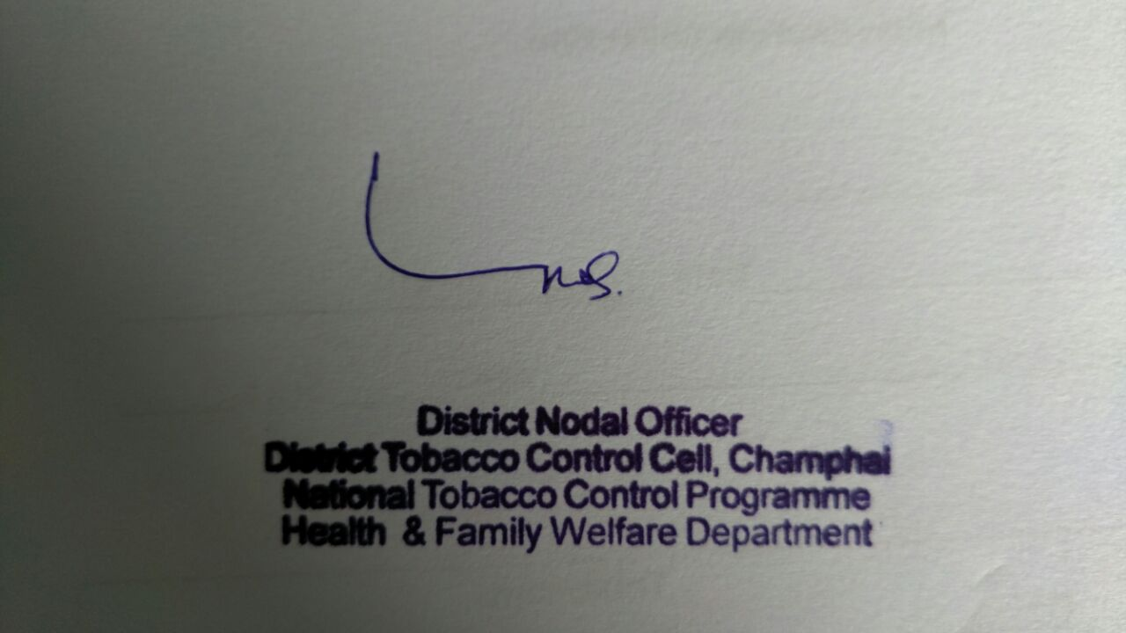

Signature & Seal
District Nodal Officer

Total No. of Challans and Fines Collected
Month & Year: April 2016
Name of the District | Section IV |  | Section V |  | Section VI |  | Section VII |  | Cumulative for all Sections
Name of the District | No. Of Challans | Fines collected | No. Of Challans | Fines collected | No. Of Challans | Fines collected | No. Of Challans | Fines collected | No. Of Challans | Fines collected
CHAMPHAI | 02 | Rs.100 | 00 | 00.00 | 00 | 00.00 | 00 | 00.00 | 02 | Rs.100.00

Total No. of Challans and Fines Collected
Month & Year: May 2016
Name of the District | Section IV |  | Section V |  | Section VI |  | Section VII |  | Cumulative for all Sections
Name of the District | No. Of Challans | Fines collected | No. Of Challans | Fines collected | No. Of Challans | Fines collected | No. Of Challans | Fines collected | No. Of Challans | Fines collected
CHAMPHAI | 00 | ₹ 00.00 | 00 | ₹ 00.00 | 00 | ₹ 00.00 | 00 | ₹ 00.00 | 00 | ₹ 00.00

Total No. of Challans and Fines Collected
Month & Year: June 2016
Name of the District | Section IV |  | Section V |  | Section VI |  | Section VII |  | Cumulative for all Sections  (4 & 7)
Name of the District | No. Of Challans | Fines collected | No. Of Challans | Fines collected | No. Of Challans | Fines collected | No. Of Challans | Fines collected | No. Of Challans | Fines collected
CHAMPHAI | 07 | Rs.350 | 00 | ₹ 00.00 | 00 | ₹ 00.00 | 00 | ₹ 00.00 | 07 | Rs.350.00

